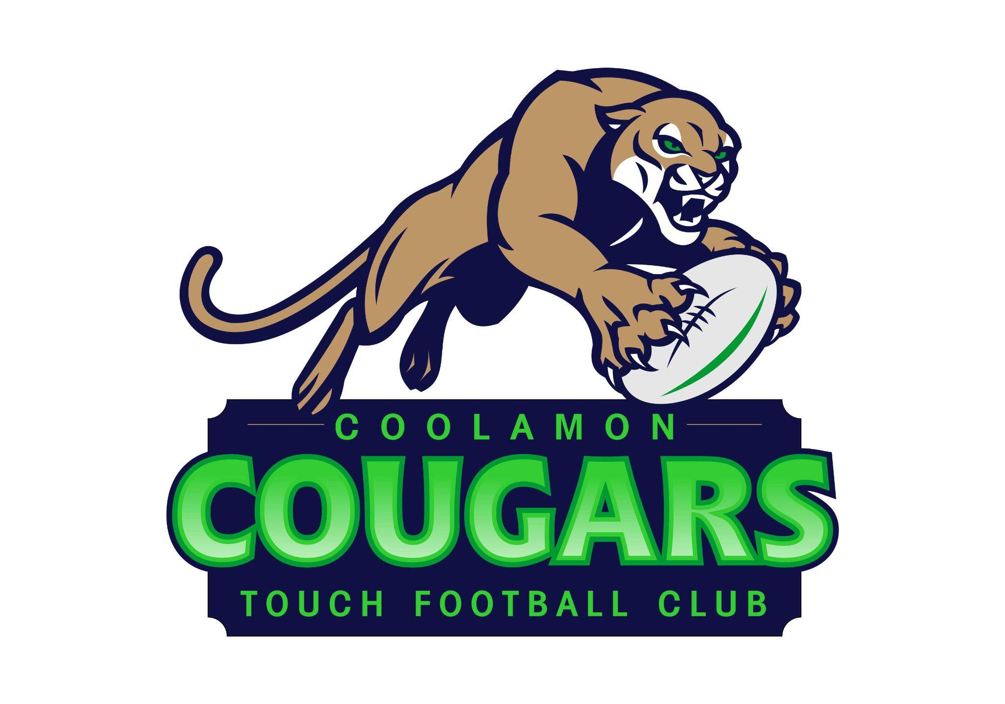

**Coolamon Touch Football Report for AGM - 21/1/2024**

**Coolamon Sport & Recreation Club**

* Governance, reporting and financials   
  Reporting requirements under Coolamon Sport & Recreation Club

AGM 21/1/2024, financial reporting and audit completed.

* Operations  
  Coolamon Touch Football operate as sub-committee under the Coolamon Sport and Recreation Club with delegated authority for operations.
* Season 2023 completed

Grand Final, last round and presentation 8/12/2023

Ice cream van, Pizza, Santa visit with lollies

Successful season - 12 rounds held

BBQ roster for garden bar with primary touch teams - worked well  
Garden Bar open, zooper doopers and Pizza - worked well  
4 Divisions & teams - Player/member data - 243 members   
Lower primary (6 teams - 64 players, 33 female, 31 male)  
Upper primary (6 teams - 56 players, 22 female, 34 male)

Secondary (5 teams - 50 players, 25 female, 25 male)

Senior mixed (8 teams - 70 players, 32 female, 38 male)  
Incidents in season with player injuries x 2 - claims to insurance

* Representative - JSC, 4 teams U10 boys/girls, U12 boys/girls  
  Successful participation.
* Uniforms   
  New uniforms for rep teams & club merch
* Grounds

Water Station - ok

Shade/seating - required  
Banners/flags - required  
Shed - OK

Fields - need to talk to council re: resurfacing, lots of holes and uneven ground

Lighting - needs upgrade for existing lights and additional lights

* Season Sponsorship  
  Local businesses for weekly awards - Coolamon Perk, The Station, Barty’s Cafe, Coffee Peddler Coolamon, Intersport Wagga Wagga  
  Coolamon Sport & Rec Club, Rural Supplies, Coolamon Foodworks, Coolamon Butchery
* Club Sponsorship   
  Beyond Bank, Coolamon Foodworks, Ezy-As 1,2,P, Hilton Concreting, Croker Grain, Commins Hendirks, Ray White Coolamon, Rural Supplies, Coolamon Pest Control.
* Grants  
  Successful Beyond bank grant application for rep uniforms $1000 contribution

Katie Francis

Touch Football Coordinator

12 December 2023