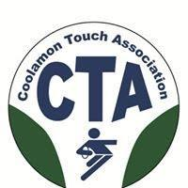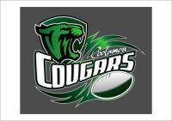

COOLAMON TOUCH ASSOCIATION INC
coolamontouchassocinc@gmail.com
PRESIDENT REPORT FOR AGM 2023

President’s Report – Position Vacant- Caretaker Sharene Mackay.
Report prepared by Coordinator - Katie Francis
Successful competition held in Season 2, 2022 (2022/2023),
10 week season with 2 rounds finals & presentation night. No finals for upper/lower primary.
Junior weekly awards for primary. End of season awards for all grades.
Competition ran from 16 September 2022 to December 2022. 12 rounds total.
Divisions – Junior: Lower primary (5 teams), upper primary (5 teams), secondary (4 teams);
Senior: open mixed (10 teams).
24 teams = 14 junior, 10 senior
227 members – 178 junior (under 18 years) & 49 senior members
Male Seniors (18+) | 37 | Female Seniors (18+) | 12
Male Juniors (U18) | 97 | Female Juniors (U18) | 81
Total Male: | 134 | Total Female: | 93
Coolamon Rovers FNC have been successful in grants to upgrade toilets/facilities block on Kindra Park, adjacent to Touch fields. Coolamon touch paid a $10,000 contribution to the project. This project is in process.
Junior touch football includes a skills session and game format for primary teams.
Junior State Cup – Wagga February 2023.
- U12 boys & girls team
- Officials
U12 boys: Mitch Robinson, Serinah Maddox, Team Manager - Sam Robinson
U12 girls: Matt Coates, George Kelleher, Alice Trevaskis, Team Manager - Kath Priest
- 3 referees - Matt Shannon, Shannon Parr & Thomas Francis
Successful season 2022, player numbers increased.
Sportsmanship awards and sponsorship from local businesses – successful.
Partnerships – Coolamon Hoppers Football Netball club. Used Kindra park toilet facilities.
Coolamon Sport and Recreation Club - opened garden bar and supported over season.
Thank you to all committee members and volunteers. Special mention & thanks to Matt Shannon - referee coordinator, Alison Foley - Junior coordinator, Siobhan Hillam - Secondary/Senior Coordinator.

